

*Exor Corporation Limited*

*The Global Leader in*

*Infrastructure Asset Management*



*Document Manager*

*User Guide v4.3*

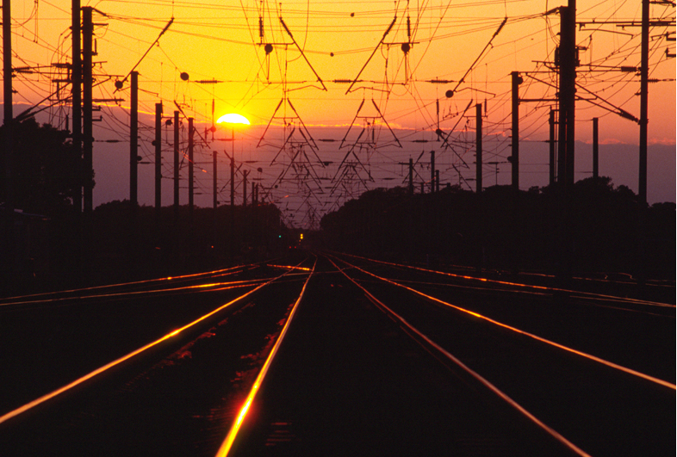

# 

This page intentionally blank

Quality Assurance Statement

|  |  |
| --- | --- |
| **Document Details** | |
| **File:**  Document Manager User Guide v4.3.pdf | **Prepared by:**  T.C. Stewart & Ian Skinner |
| **Manual Name:**  Document Manager User Guide | **Reviewed by:**  **Ian Skinner** |
| **Version:**  3.0 | **Approved for issue by:**  T.C. Stewart |
| **Date of Issue:**  Nov 2008 | **Product Manager:**  T.C. Stewart |
| **File Name:**  Document Manager User Guide v4.3.pdf | |

|  |  |  |  |  |
| --- | --- | --- | --- | --- |
| **Document Version Control** | | | | |
| **Revision** | **Date** | **By** | **Chapter / Page** | **Description** |
| 3.0 | Nov 2010 | IS | All | Updated for 4.3 release |

CONTENTS

[Quality Assurance Statement 1](#_Toc278545753)

[Document Associations - DOC0120 4](#_Toc278545754)

[Document Associations 5](#_Toc278545755)

[Document Additional Details 6](#_Toc278545756)

[Create from Template Button 6](#_Toc278545757)

[Create from New Button 8](#_Toc278545758)

[Edit File Button 9](#_Toc278545759)

[Document Details 10](#_Toc278545760)

[Create association via Keyword Search 11](#_Toc278545761)

[Displaying Documents 12](#_Toc278545762)

[Displaying Documents via a URL 12](#_Toc278545763)

[Displaying Documents via a Client Viewer 13](#_Toc278545764)

[General Information 15](#_Toc278545765)

[Prerequisites 15](#_Toc278545766)

[Creating a Word Template 16](#_Toc278545767)

[Creating a MS Word Template 17](#_Toc278545768)

[Defining a new template 18](#_Toc278545769)

[Example Templates - Enquiry Manager 19](#_Toc278545770)

[Example Templates - Works Order 21](#_Toc278545771)

[Integer Value for WO Line 25](file:///C:\Users\ian.skinner\Documents\SharePoint%20Drafts\Document%20Manager%20User%20v4.3.docx#_Toc278545772)

[Maintain Templates - DOC0120 27](#_Toc278545773)

[Template Columns 29](#_Toc278545774)

[Resequence 30](#_Toc278545775)

[Copy Template 30](#_Toc278545776)

[Check Template SQL 31](#_Toc278545777)

[Template Users - DOC0202 33](#_Toc278545778)

[Template Type 33](#_Toc278545779)

[Templates 34](#_Toc278545780)

[Exor Functions 35](#_Toc278545781)

[Exor Functions available for use with 'DOCS' (Public Enquiry )Templates 35](#_Toc278545782)

[Exor Functions available for use with 'WORK ORDERS' Templates 36](#_Toc278545783)

Chapter

1

Using Document Manager Interface

This chapter describes how to use the document management interface from within an ***Exor*** form.

Many of the forms within ***Exor have*** access to the Document Manager interface which allows the user to associate documents with any information in the database. Once defined, documents may be associated with multiple database objects. The following option is available and should only be called from within a ***Exor*** form.

* Document Associations - DOC0120

The form description provides you with detailed information about the Document Manager form in ***Exor***, including:

* an overall description of the form.
* a detailed explanation of each field, including available features (such as List of Values), default values and other characteristics.
* Helpful information for using the form.

Document Associations - DOC0120

Figure 1

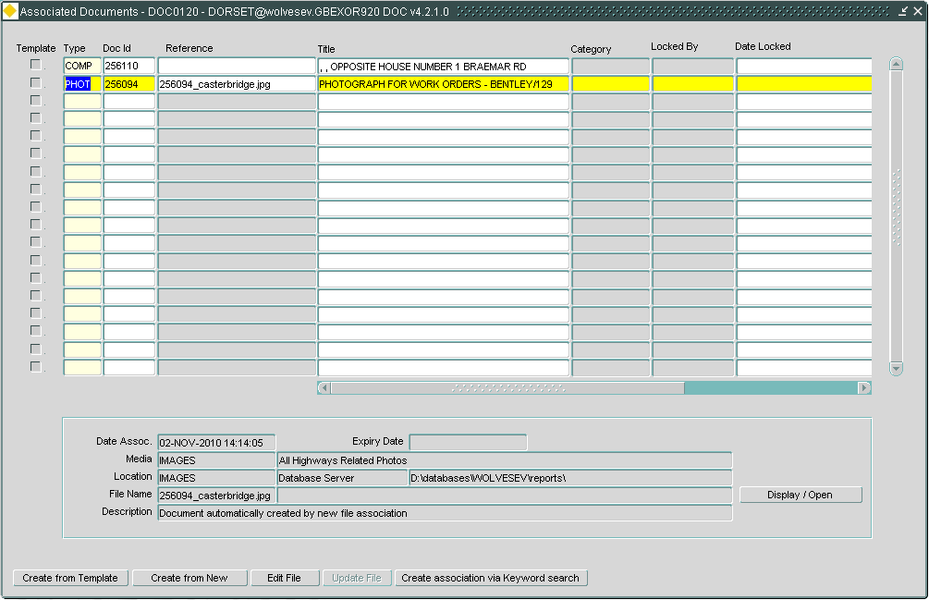Document Associations

This form may be called from within any form that has access to ***Document Manager*** by pressing the [**Document**] button on the Exor toolbar. It is used to associate new documents or images etc. with the current object or to display or manipulate already associated documents.

If the current database object does not have any documents associated with it the  [**Document**] button on the menu toolbar will have a diagonal line through it. If it has documents associated with it the button will have a tick mark overlaid on the button.

Document associations may be made with the selected record by either predefining the document using the ***Documents - DOC0100*** form, or by using the [**Create from New**] button on the Document Associations window. This allows you to associate a file with an object and automatically creates the Document record in ***Documents - DOC0100.***

Document Associations

When you enter this window any previously associated documents will be displayed. To associate a new document press [**Create Record**] or press [**F6**].

To associate a Predefined Document enter the following details:

Type (Required) (List)

Enter the document type. These will have been previously set up using ***Document Types /Classes - DOC0110*** (see Document Manager System Admin Guide).

Doc Id (Required) (List)

Enter the document id that is to be associated with the selected record. The document type selected in the previous field will determine the List of Values. These will have been previously set up using ***Documents - DOC0100*** (see Document Manager System Admin Guide).

Reference (Display Only)

The document Reference No. will be displayed.

Title (Display Only)

The document Title will be displayed.

Category (Optional) (List)

Enter the category of the document. These will have been previously setup and can be added to using ***Domains – HIG 9120*** and updating the DOC\_CATEGORIES option

If the [Edit File] button has been selected the following fields will be populated:

Locked By (Display Only)

The user id that is editing the document will be displayed.

Date Locked (Display Only)

The date the document was locked will be displayed

Terminal (Display Only)

The terminal or server id of the user that locked the record will be displayed.

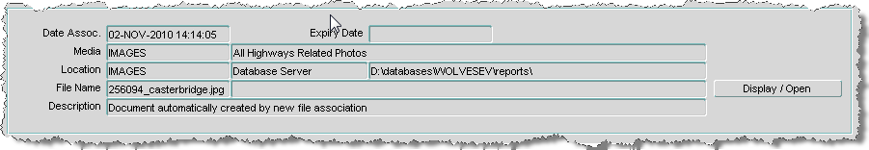Figure 2

Additional Details

Document Additional Details

The following additional details for the currently selected document will be displayed:

* Date Associated
* Expiry Date
* Media Type with associated description
* Location type with associated description and location
* File name
* File Description

The [Display / Open] button will display the document or open it with the appropriate tool for the selected document.

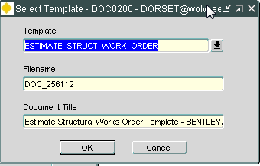

Figure 3

Create from

Template

Create from Template Button

The [Create from Template] button will display the dialogue window above allowing the user to select a template for use with the data in the associated module.

The content of the picklist is context sensitive and will only display those templates that are appropriate for the module the user is using when *Document Associations - DOC0120* was called.

When the [OK] button is selected the template will be displayed and the fields will be populated.

The file created will be generated on the Application Server and transferred to the Document Location.

If the 'Print Immediate' checkbox was ticked in ***Template Users - DOC0202*** the document will be printed directly to the default printer for that Client PC. If it was not ticked, Exor will load MS-Word and open the document. This allows the user to modify the document and printer properties.

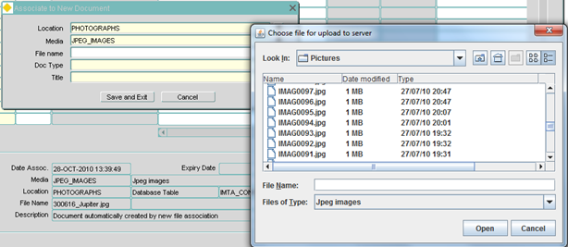Figure 4

Associate to

New Document

Create from New Button

The **[Create from New]** button on the Document Associations window allows users to associate a document that has **not** yet been defined in ***Documents - DOC0100***. This is a very quick and easy method of associating documents with database objects as a 'Find File' facility is also available, enabling users to browse their system to locate the required document.

To associate a New Document using the **[Create from New]** button enter the following details:

Location (Required) (List)

Enter the operating system location name of the document file. This will have been previously set up using ***Media Types - DOC0118*** (see Document Manager System Admin Guide).

Media (Required, Default) (List)

Enter the format that the file exists in on the system. The default is the media type set up using ***Media Types - DOC0118*** (see Document Manager System Admin Guide),.but this value may be changed if required.

Filename (Required) (List)

The user has to choose the required Document Location and Media Type before selecting the filename.

The file picker is filtered using the Extension data from the Media Type. The file will be uploaded with a progress bar displaying the status.

Note that you should include the DOS extension if the filename includes one.

Doc Type (Required) (List)

Select an appropriate document type for the selected document.

Title (Required)

Enter a title for the selected document.

Edit File Button

The **[Edit File]** button allows users to ‘lock’ a file for editing. The button text will change to **[Unlock File]** while the file is being edited.

This is only appropriate when using a Database Table Document Location.

To lock a file, you select the **[Edit File]** button, this will download a copy of the file onto your PC. The document is then ‘soft locked’ and prevents other edits from the application. However, other users are still allowed to Display the file.

Once the file has been locked the display in Associated Documents – DOC0120 is changed as follows:

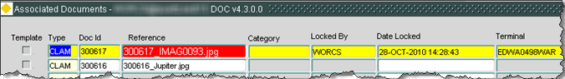

Figure 5

Lock File

The file can then be edited and uploaded back with [Update File], this will upload the file from your Work folder back into the Oracle Table, keeping it locked for further edit.

Or the lock can be released with the [Unlock File] button which will return the document to the Oracle Table.

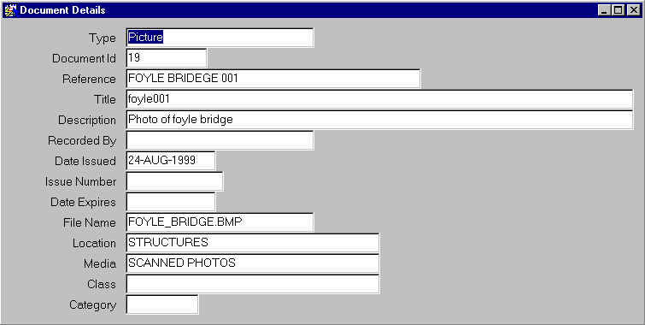Figure 6

Document Details

Document Details

To view more details of a document you can press the [**EXPAND**] button.

1. Use the [**UP**] and [**DOWN**] arrows to move the cursor to the required document.
2. Press the [**EXPAND**] button or press [**SHIFT**] +[**F3**].

The following information will be displayed for the document:

* Type
* Document ID
* Reference
* Title
* Description
* Recorded By
* Date Issued
* Issue Number
* Date expires
* File Name
* Location
* Media
* Class
* Category

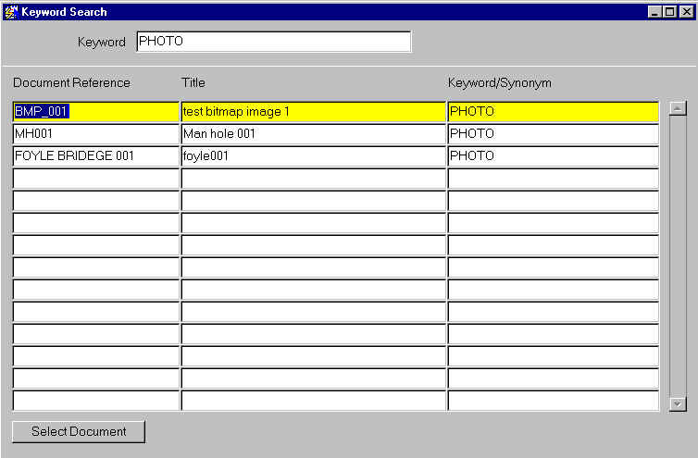Figure 7

Document Association: Keyword Search

Create association via Keyword Search

This form is used to search for documents by looking for the keyword that was associated with the document using Documents Keywords function in ***Documents - DOC0100*** (see Document Manager System Admin Guide).

Keyword (Required) (List)

Enter the keyword you wish to search for.

To view list of documents the search has queried back click in the document window. The cursor sits in the Document Reference field. To associate a document with the currently selected object do the following:

1. Use the [**UP**] and [**DOWN**] arrows to move the cursor to the required document.
2. Press the [**SELECT RECORD**] Button

This will associate the chosen document the currently selected object and close the Keyword Search window. Before closing the Document Association window you must [**SAVE**] the changes to the database.

Displaying Documents

When a document is displayed, there are two methods of doing so. These methods are constant across both ***Documents - DOC0100***  and ***Document Associations - DOC0120*** modules.

Displaying Documents via a URL

When a Document Location has a URL defined, the document will be opened via a URL in the internet browser. An example of this is shown below:

Depending on how your browser is configured to accept new links, it will open in a new window or a new tab. This will require navigating to.

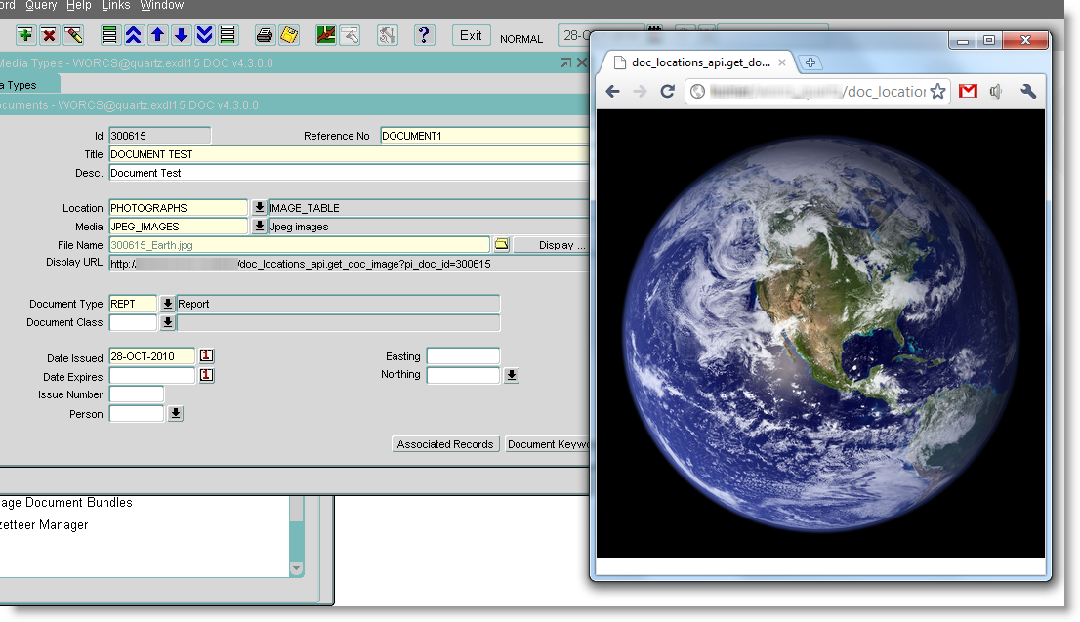Figure 8

Display

Via a URL

Displaying Documents via a Client Viewer

When displaying a document from a Document Location without a URL set, the application will download a copy of the file to your work folder, and display it on the client PC in it’s native application. So, for example, if your PC is configured to open JPGs in a specified Viewer, it will use that application.

An example of this is shown below:

This is configurable from your Windows Control Panel.

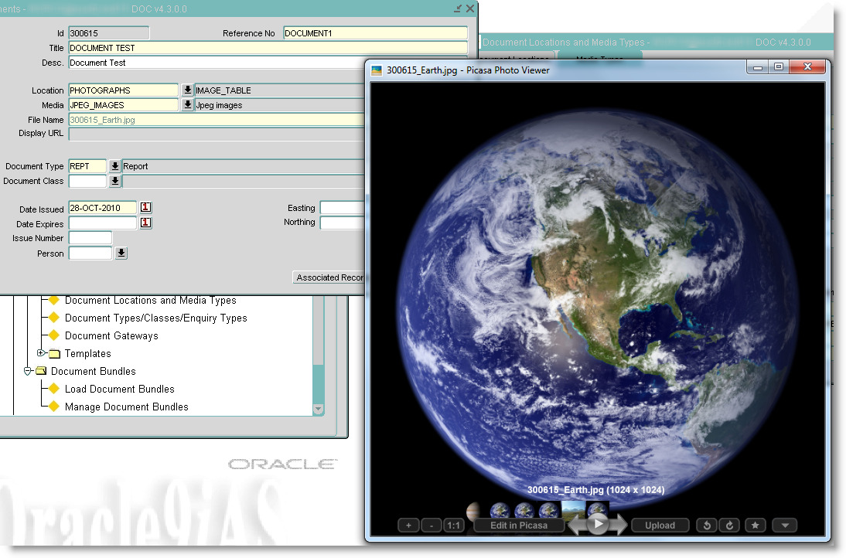Figure 9

**Display via**

**Client Viewer**

Chapter

2

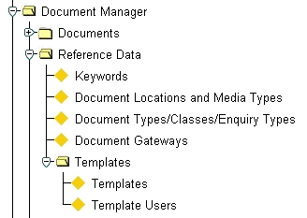Templates

Figure 10

Templates Menu

This chapter describes the forms that are used for creating and managing templates and associating them with objects (Works Orders, Public Enquiries etc.) held within the ***Exor*** database. They are the following forms:

* Maintain Templates - DOC0201
* Templates Users - DOC0202
* Document Associations - DOC0120

This chapter also describes how to create a Template using Microsoft Word.

The form description provides you with detailed information about the Document Manager forms in ***Exor***, including:

* an overall description of the form.
* a detailed explanation of each field, including available features (such as List of Values), default values and other characteristics.
* Helpful information for using the form.

General Information

***Document Manager*** enables users to create and define their own report templates, using Microsoft Word. These templates can be used toprint data relating toany object in the ***Exor*** database in a user-defined format. The resulting Word document is automatically linked, as a new document, to the database object for future reference. This facility also allows the user to define a number of different templates against the same database object to cater for varying report styles and operational outputs. Typical uses are the production of standard responses to letters of complaint or enquiry from the public and the production of user-defined works order forms.

A set of sample templates is supplied with Exor, and can be found in the exor\cor\template directory.

Prerequisites

The flow diagram below indicates the information that needs to be set up prior to printing your report templates.

Create Template using MS-Word

Check Media Types

(DOC0118)

Template Users

(DOC0202)

Document Associations

(DOC0120)

Maintain Template

(DOC0201)

Creating a Word Template

A template is a file containing the information that gives a document its design. It can contain many elements, such as text, pictures, formatting and styles. Every Word document has a template attached to it. When a Word document is created it inherits all the components of the template.

Before creating your new template document you should design the template on paper and determine which 'exor data fields' you want to include on your template. To view a data field's name (this will be needed to relate the template bookmark with the associated exor data field follow this procedure:

1. Navigate to the required form e.g. Public Enquiries.
2. Press the [**Enter Query**] button on the toolbar or press [**F6**]. This will allow you to access more of the form fields.
3. Click in the required form field.
4. Press [**F1**]. The field name will be displayed on the Status Line e.g. DOC\_COMPL\_NAME.

Some of the information you require to be displayed on your template may not be held in the database table that you have selected to link to your MS Word template using ***Maintain Templates - DOC0201***. For example, if you are creating a template for use with ***public enquiry manager***, you will select the table DOCS, as this is where the data is stored. If however you wanted to display the full name of the person responsible for a public enquiry, this would not be possible using exor data field names as only the person's User Id code is stored in the DOCS table.

To allow 'lookups' to other tables *exor functions* can be utilized to 'bring in' data from other tables. The above example would use the following function:

COMPLAINTUSER(DOC\_COMPL\_USER\_ID)

Where 'COMPLAINTUSER' is the function name and DOC\_COMPL\_USER\_ID is the lookup parameter.

A full list of exor functions currently available can be found on page 36.

Once you have designed your template you can start to define it in Microsoft Word.

Figure 11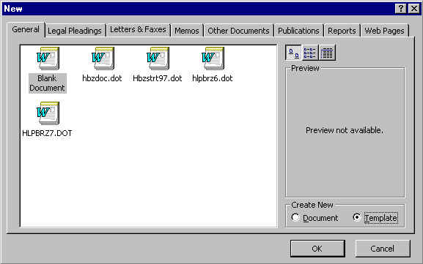

Create a new template in MS-Word

Creating a MS Word Template

A Microsoft Word 'template' is a special type of Word document, identified by the filename extension '. dot’ rather than '.doc'. It looks like a standard Word document but it contains embedded ‘fields’ that allow data from an external source (in this case, the ***Exor*** database) to be dropped in to the document.

* Within Microsoft Word, design your template using a combination of standard text, drawing and table elements. There are several points to bear in mind when creating templates in Word.
* It is suggested that Microsoft Word version 7.0 or higher should be used as earlier versions appear to manage fields in a different manner.
* When drawing boxes in Microsoft Word, do not use the Frames tool. Instead use the drawing tools available on the Drawing Toolbar. This can be found under the 'View' 'Toolbars' menu.
* Remember to leave sufficient room for the data that will be 'dropped in' to your template from the *Exor* system.
* Remember that if you have more than one field on a line, the exor data will cause the text, which follows it on the line to be shifted along accordingly. It is suggested that the Table Tool be used if this is the case, as text will 'wrap' within a cell and not cause any subsequent text to be shifted. Take this into consideration when designing your templates.

Defining a new template

To define a new MS-Word template carry out the following steps:

1. Start Microsoft Word
2. Select the **File** menu.
3. Select the **New** command. Ensure that the 'Blank Document' icon is selected.
4. Under **Create New**, select the **Template** option
5. Select **OK**.

This will create a new blank template ready for you to enter the required text and data fields. Before beginning to define your template, ensure that the 'Forms' toolbar is visible (Figure 12). This can be accessed through the '**View** → **Toolbars** →**Forms**' menu.

Figure 12word_form_toolbar

Forms Toolbar

Entering text in a template is the same as entering text in a document. You can use styles, formatting, drawing tools, etc. to achieve the look you require for you template. Company Logo's etc may also be added in the 'header' or 'footer' to give your template and resulting documents a corporate appearance. When you want to insert an exor data field into your Word Template carry out the following steps:

1. Ensure the cursor is at the start of the space into which you want to insert your exor data.
2. Click the 'Text Form Field’ button  on the 'Forms' toolbar. This will place a short gray box in the template to represent the field.
3. 'Right Click' on the gray box and select the 'Properties' option (if using Word v 7.x select 'Form Field Options'). This will display the 'Text Form Field Options' window.
4. In the 'Default Text' field, type a short description of the contents of the field. This will appear on your template to show you where the data will be inserted and also the format of the text (font, size, etc.). It is suggested that this description is the same name that is used in the 'Bookmark' field. This will make assigning the 'Word Field Name' to the exor data field name much easier.
5. In the 'Bookmark' field, give the field a short name to uniquely identify it (e.g. ACK\_NAME). This will be used to link the field to the ***Exor*** system using ***Maintain Templates - DOC0201***
6. Press [**OK**].

When you have completed your template design, save it in the appropriate Windows directory as a Word Template (.dot). The template must be saved in a location already defined using ***Media Types - DOC0118*** (see Document Manager System Admin Guide).

Example Templates - Enquiry Manager

This example is a template for an Acknowledgement letter for enquiries recorded using enquiry manager. To display the required information *exor Functions* will be used for certain form fields.

|  |
| --- |
| Example County Council  Department Of Engineering  Civic Centre  Main Street  Anytown |

26-Nov-10

|  |  |
| --- | --- |
| ack\_name | Our Ref : ack\_ref |
| ack\_add1 | |
| ack\_add2 | |
| ack\_add3 | |
| ack\_add4 | |
| ack\_add5 | |
| ack\_post\_code | |

Dear Sir/Madam

I refer to your communication by ack\_source received on ack\_received concerning;

ack\_text, ack\_loc, ack\_road\_desc.

This is being dealt with by ack\_resp. I will keep you informed as to the progress of your enquiry.

Yours Faithfully

Section Engineer

The following exor data is brought into this template and is setup in **Maintain Templates - DOC0201** fields.

|  |  |  |  |
| --- | --- | --- | --- |
| **Form Field Name** | **Table Column/Field Name** | **Function Name and Parameters used** | **Details Returned** |
| Ack\_ref | DOC\_ID |  | Enquiry ID |
| Ack\_name | DOC\_COMPL\_NAME |  | Complainant Name |
| Ack\_add1 | DOC\_COMPL\_ADDRESS1 |  | Address Line 1 |
| Ack\_add2 | DOC\_COMPL\_ADDRESS2 |  | Address Line 2 |
| Ack\_add3 | DOC\_COMPL\_ADDRESS3 |  | Address Line 3 |
| Ack\_add4 | DOC\_COMPL\_ADDRESS4 |  | Address Line 4 |
| Ack\_add5 | DOC\_COMPL\_ADDRESS5 |  | Address Line 5 |
| Ack\_post\_code | DOC\_POST\_CODE |  | Postcode |
| Ack\_source |  | COMPL\_SOURCE(DOC\_ID) | Description of Source |
| Ack\_received | DOC\_DATE\_ISSUED |  | Date Recorded |
| Ack\_text | DOC\_DESCR |  | Enquiry Text |
| Ack\_loc | DOC\_COMPL\_LOCATION |  | Enquiry Location |
| Ack\_road\_desc |  | COMPL\_ROAD\_DESCR(DOC\_ID) | Road Description |
| Ack\_resp |  | COMPLAINTUSER(DOC\_COMPL\_USER\_ID) | Name of Responsible person |

Note that the Date was entered using the 'Insert' → 'Date and Time' option within MS-Word.

The resulting document created using this template would be displayed with the appropriate Exor data like this:

|  |
| --- |
| Example County Council  Department Of Engineering  Civic Centre  Main Street  Anytown |

26-Nov-10

|  |  |
| --- | --- |
| ack\_name | Our Ref : ack\_ref |
| ack\_add1 | |
| ack\_add2 | |
| ack\_add3 | |
| ack\_add4 | |
| ack\_add5 | |
| ack\_post\_code | |

Dear Sir/Madam

I refer to your communication by ack\_source received on ack\_received concerning;

ack\_text, ack\_loc, ack\_road\_desc.

This is being dealt with by ack\_resp. I will keep you informed as to the progress of your enquiry.

Yours Faithfully

Section Engineer

Example Templates - Works Order

This example is a template for a Works Order. To display the required information *exor Functions* will be used for certain form fields

|  |  |  |  |  |  |  |  |  |  |  |  |  |  |  |
| --- | --- | --- | --- | --- | --- | --- | --- | --- | --- | --- | --- | --- | --- | --- |
| Dtp/Local  NETWORK\_INDICATOR | | Agency | | Road Group  ROAD\_GROUP | Job Number  JOB\_NUMBER |  | | Contract  CONTRACT | | Works Order No  ORDER\_NO | | | | |
| Commence by: COMMEN\_BY Rev Compl by: COMPLT\_BY  Complete by: COMPLETE\_BY Completed On: COMPLETED\_ON  Def. Corr. Period: DEF\_CORRECTION Interim Pay: INTERIM  Commenced On: COMMENCED\_ON CI 14 Prog.: PROG\_FLAG  Quality Acc.: QUALITY\_ACC Risk Assessment: RISK\_ASS  Ext of Time: EXTEN\_TIME Method Statement: METHOD  Special CDM: SPECIAL\_CDM | | | | | | | | Raised by: RAISED\_BY Date: DATE\_RAISED  Authorised by: AUTHORISED\_BY  Completed by \_\_\_\_\_\_\_\_\_\_\_\_\_\_\_\_\_\_\_ Date : \_\_\_\_\_\_\_\_\_\_\_ | | | | | | |
| Description of Work: WOR\_DESCR  Std\_Text | | | | | | | | Sub Total :  Balancing Sum:  Works order Total: | | | | SUB\_TOTAL  BAL\_SUM  ORDER\_TOTAL | | |
| Defect | Road Section | | Defect Location Details | | | | SOR Item | | Unit | | Rate | | Qty | Amount |
| WOL\_DEFECT\_ID\_1 | WOL\_ROAD\_SECTION\_1 | | DEF\_LOC\_1 | | | | WOL1\_BOQ\_LINE1WOL1\_BOQ\_LINE2WOL1\_BOQ\_LINE3WOL1\_BOQ\_LINE4WOL1\_BOQ\_LINE5  BOQ\_LINE\_TOTAL\_1 | | | | | | | |
| WOL\_DEFECT\_ID\_2 | WOL\_ROAD\_SECTION\_2 | | DEF\_LOC\_2 | | | | WOL2\_BOQ\_LINE1WOL2\_BOQ\_LINE2WOL2\_BOQ\_LINE3WOL2\_BOQ\_LINE4WOL2\_BOQ\_LINE5  BOQ\_LINE\_TOTAL\_2 | | | | | | | |
| WOL\_DEFECT\_ID\_3 | WOL\_ROAD\_SECTION\_3 | | DEF\_LOC\_3 | | | | WOL3\_BOQ\_LINE1WOL3\_BOQ\_LINE2WOL3\_BOQ\_LINE3WOL3\_BOQ\_LINE4WOL3\_BOQ\_LINE5  BOQ\_LINE\_TOTAL\_3 | | | | | | | |
|  |  | |  | | | |  | | | | | | | |
|  |  | |  | | | |  | | | | | | | |

The following exor data is brought into this template and is setup in **Maintain Templates - DOC0201**.

|  |  |  |  |
| --- | --- | --- | --- |
| **Form Field Name** | **Table Column/Field Name** | **Function Name and Parameters used** | **Details Returned** |
| NETWORK\_INDICATOR |  | WWO.GET\_NETWORK\_IND(WOR\_WORKS\_ORDER\_NO) | **D** for Dtp or **L** for Local |
| ROAD\_GROUP |  | WWO.GET\_ROAD\_GROUP(WOR\_WORKS\_ORDER\_NO) | Road Group on Works Order e.g. 2900A69 1 |
| JOB\_NUMBER | WOR\_JOB\_NUMBER |  | Job Number |
| CONTRACT |  | WWO.GET\_CONTRACT(WOR\_WORKS\_ORDER\_NO) | Contract Name |
| ORDER\_NO | WOR\_WORKS\_ORDER\_NO |  | Works Order Number |
| COMMEN\_BY | WOR\_COMMENCE\_BY |  | Commence by Date |
| COMPLETE\_BY | WOR\_EST\_COMPLETE |  | Complete by Date |
| DEF\_CORRECTION | WOR\_DEF\_CORRECTION\_PERIOD |  | Defect Correction Period |
| COMMENCED\_ON | WOR\_ACT\_COMMENCE\_BY |  | Commenced On Date |
| QUALITY\_ACC | WOR\_DEF\_CORRECTION\_ACCEPTAB |  | Quality Acceptable Flag |
| COMPLT\_BY | WOR\_REVISED\_COMP\_DATE |  | Revised Complete By Date |
| COMPLETED\_ON | WOR\_DATE\_CLOSED |  | Completed On Date |
| INTERIM | WOR\_INTERIM\_PAYMENT\_FLAG |  | Interim Payment Flag |
| PROG\_FLAG | WOR\_WORKS\_PROGRAMME\_FLAG |  | Works Programme Flag |
| METHOD | WOR\_METHOD\_STATEMENT\_FLAG |  | Method Statement Issued Flag |
| SPECIAL\_CDM | WOR\_ADDITIONAL\_SAFETY\_FLAG |  | Additional Safety Flag |
| RAISED\_BY |  | WWO.RAISED\_BY(WOR\_WORKS\_ORDER\_NO) | Name of User who raised the Works Order |
| DATE\_RAISED | WOR\_DATE\_RAISED |  | Date Works Order Raised |
| AUTHORISED\_BY |  | WWO.AUTHORISED\_BY(WOR\_WORKS\_ORDER\_NO) | Name of the User who Authorised the WO |
| WOR\_DESCR | WOR\_DESCR |  | Works Order Description |
| SUB\_TOTAL |  | WWO.GET\_ORDER\_SUB\_TOTAL(WOR\_WORKS\_ORDER\_NO) | Works Order Sub-Total |
| BAL\_SUM |  | WWO.GET\_ORDER\_BAL\_SUM(WOR\_WORKS\_ORDER\_NO) | Works Order Balancing Sum |
| ORDER\_TOTAL |  | WWO.GET\_ORDER\_TOTAL(WOR\_WORKS\_ORDER\_NO) | Total Works Order Cost |
| WOL\_DEFECT\_ID1 |  | WWO.GET\_DEFECT\_ID(WWO.GET\_WOL\_ID(1,WOR\_WORKS\_ORDER\_NO)) | Defect Id of Works Order Line 1 |
| WOL\_ROAD\_SECTION\_1 |  | WWO.GET\_WOL\_ROAD\_SECTION(WWO.GET\_WOL\_ID(1,WOR\_WORKS\_ORDER\_NO)) | Link Id and Section Num. for the defect on the WO line 1 e.g. 2900A69 1/06 |
| DEF\_LOC\_1 |  | WWO.GET\_DEFECT\_LOC(WWO.GET\_WOL\_ID(1,WOR\_WORKS\_ORDER\_NO)) | Road Description, Defect Location, Defect Type and Description for defect on WO line1 |
| WOL1\_BOQ\_LINE1 |  | WWO.GET\_BOQ\_LINE(1,WWO.GET\_WOL\_ID(1,WOR\_WORKS\_ORDER\_NO)) | BOQ Item Code and Description for BOQ Line 1 of WO Line 1 |
| WOL1\_BOQ\_LINE2 |  | WWO.GET\_BOQ\_LINE(2,WWO.GET\_WOL\_ID(1,WOR\_WORKS\_ORDER\_NO)) | Unit of measurement of BOQ line 1 of WO Line 1 |
| BOQ\_LINE\_TOTAL\_1 |  | WWO.GET\_BOQ\_LINE\_TOTAL(WWO.GET\_WOL\_ID(1,WOR\_WORKS\_ORDER\_NO)) | Total Cost for WO Line 1 |

Some functions require an integer value to define, for example, the Works Order Line that data is to be selected from. This is demonstrated in the function used to 'drop in' the Defect Id from a Works Order Line.

**WWO.GET\_DEFECT\_ID(WWO.GET\_WOL\_ID(1,WOR\_WORKS\_ORDER\_NO))**

Integer Value for WO Line

The number '1' in this example tells the function to get the Defect ID from Works Order Line 1 of the selected Works Order. If the Defect Id from Works Order Line 2 was also required, the function would be duplicated, but the '1' would be replaced with '2'. This procedure may be repeated many times to meet your requirements.

Another example of integer values being used is the function that 'drops in' the BOQ Item Code and Description.

**WWO.GET\_BOQ\_LINE(1,WWO.GET\_WOL\_ID(1,WOR\_WORKS\_ORDER\_NO))**

Integer value for BOQ Line

Integer value for Works Order Line

This function uses two integer values. The first tell the function which BOQ line to use and the second tells the function which Works Order Line to use from the selected Works Order. To select the second BOQ line of Works Order Line 1 the function would be as follows:

**WWO.GET\_BOQ\_LINE(2,WWO.GET\_WOL\_ID(1,WOR\_WORKS\_ORDER\_NO))**

A sample list of available functions is displayed on page 36.

The resulting document created using this template would be displayed with the appropriate exor data like this:

|  |  |  |  |  |  |  |  |  |  |  |  |  |  |
| --- | --- | --- | --- | --- | --- | --- | --- | --- | --- | --- | --- | --- | --- |
| Dtp/Local  NETWORK\_INDICATOR | | Agency | | Road Group  ROAD\_GROUP | Job Number  JOB\_NUMBER |  | | Contract  CONTRACT | | Works Order No  ORDER\_NO | | | |
| Commence by: COMMEN\_BY Rev Compl by: COMPLT\_BY  Complete by: COMPLETE\_BY Completed On: COMPLETED\_ON  Def. Corr. Period: DEF\_CORRECTION Interim Pay: INTERIM  Commenced On: COMMENCED\_ON CI 14 Prog.: PROG\_FLAG  Quality Acc.: QUALITY\_ACC Risk Assessment: RISK\_ASS  Ext of Time: EXTEN\_TIME Method Statement: METHOD  Special CDM: SPECIAL\_CDM | | | | | | | | Raised by: RAISED\_BY Date: DATE\_RAISED  Authorised by: AUTHORISED\_BY  Completed by \_\_\_\_\_\_\_\_\_\_\_\_\_\_\_\_\_\_\_ Date : \_\_\_\_\_\_\_\_\_\_\_ | | | | | |
| Description of Work: WOR\_DESCR  Std\_Text | | | | | | | | Sub Total :  Balancing Sum:  Works order Total: | | | | SUB\_TOTAL  BAL\_SUM  ORDER\_TOTAL | |
| Defect | Road Section | | Defect Location Details | | | | SOR Item | | Unit | Rate | Qty | | Amount |
| WOL\_DEFECT\_ID\_1 | WOL\_ROAD\_SECTION\_1 | | DEF\_LOC\_1 | | | | WOL1\_BOQ\_LINE1WOL1\_BOQ\_LINE2WOL1\_BOQ\_LINE3WOL1\_BOQ\_LINE4WOL1\_BOQ\_LINE5  BOQ\_LINE\_TOTAL\_1 | | | | | | |
| WOL\_DEFECT\_ID\_2 | WOL\_ROAD\_SECTION\_2 | | DEF\_LOC\_2 | | | | WOL2\_BOQ\_LINE1WOL2\_BOQ\_LINE2WOL2\_BOQ\_LINE3WOL2\_BOQ\_LINE4WOL2\_BOQ\_LINE5  BOQ\_LINE\_TOTAL\_2 | | | | | | |
| WOL\_DEFECT\_ID\_3 | WOL\_ROAD\_SECTION\_3 | | DEF\_LOC\_3 | | | | WOL3\_BOQ\_LINE1WOL3\_BOQ\_LINE2WOL3\_BOQ\_LINE3WOL3\_BOQ\_LINE4WOL3\_BOQ\_LINE5  BOQ\_LINE\_TOTAL\_3 | | | | | | |
| WOL\_DEFECT\_ID\_4 | WOL\_ROAD\_SECTION\_4 | | DEF\_LOC\_4 | | | | WOL4\_BOQ\_LINE1WOL4\_BOQ\_LINE2WOL4\_BOQ\_LINE3WOL4\_BOQ\_LINE4WOL4\_BOQ\_LINE5  BOQ\_LINE\_TOTAL\_4 | | | | | | |

Maintain Templates - DOC0120

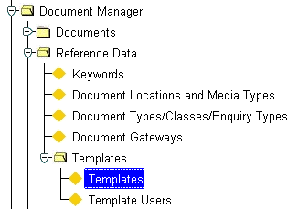Figure 13

Maintain Templates

Menu Option

This form is used to define the location of your templates and specify which ***Exor*** table and subsequent fields should be 'dropped in' to the template to form your final printed document.

Figure 14

Templates 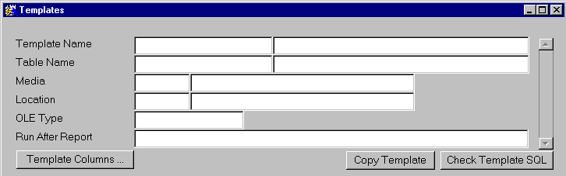

When you enter this form the cursor sits in the Template Name field waiting for you to enter the name of the template you wish to maintain. To display existing data press [**Enter Query**] or press [**F7**], enter your selection criteria, then press [**Execute Query**] or press [**F8**] (a list of previously defined templates is available).

Template Name (Required)

Enter the name of the Template. This must be the same as the filename you called your Microsoft Word .dot file. You do not need to enter the '.dot' file extension. A description of the Template can be entered in the adjacent field.

Table Name (Required) (List)

Enter the table name to containing the required data e.g. for a public enquiry this will be 'DOCS', for Works Orders this will be 'WORK ORDERS'. The table description will be displayed in the adjacent field.

Media (Required) (List)

Enter the media type for this template. These will have been set up previously using ***Document Locations and Media Types - DOC0118*** (see Document Manager System Admin Guide). The media name will be displayed in the adjacent field.

Location (Required) (List)

Enter the Location where the Microsoft Word '.dot' file can be found. These will have been set up previously using ***Document Locations and Media Types - DOC0118***. The Location name will be displayed in the adjacent field.

OLE Type (Required)

Enter the following text '**WORD**'

Run After Report (Optional) (List)

This field is used, if required, to select a procedure to run after the template document has been produced. An example of this is the procedure CREATE\_COMPLAINT\_HISTORY, which creates an Enquiry History record ( Public Enquiry Manager Manual) for the selected public enquiry when a template report is created for it.

Note that this field must be used in conjunction with the 'Used in Procedure' check box in Template Columns.

Figure 15

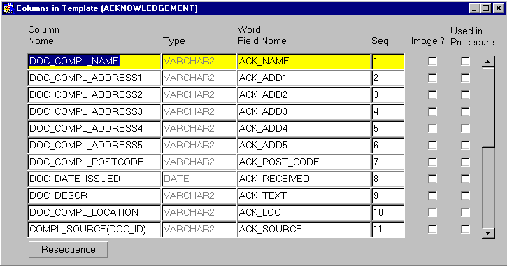Template Columns

Template Columns

This window is used to associate the Column (field) Names in the ***Exor*** data table selected in the 'Table Name' field on the Maintain Templates form, with the MS Word Field Name in the selected template. This will allow the appropriate data to be dropped into the MS Word Template to produce the document report.

When you enter this window any previously entered Column details will be displayed and the cursor sits in the 'Column Name' field. To add further Column Details Click on the next available blank line.

Column Name (Required) (List)

Enter the Column (Field) Name to be inserted into your template. The contents of the pick list will be determined by the 'Table Name' selected in the Maintain Templates window.

Type (Display Only)

The type of column selected will be displayed e.g. Date or VARCHAR2

Word Field Name (Required)

Enter the 'Bookmark' field name assigned to this field whilst creating the template e.g. ack\_ref

Sequence (Required)

Enter the sequence number for this field. This is the order in which the fields on the chosen template will be populated. It is suggested that these are incremented in steps of 5 or 10 (i.e. 5,10,15,12… or 10,20,30,40…) to allow further Column details to be added easily later.

Used in Procedure (Check box)

Click this check box if this field is to be used in a procedure that has been defined in the 'Run After Report' field in the Maintain Templates form. For example, if the Procedure CREATE\_COMPLAINT\_HISTORY is used to run after a report in a public enquiry template, the Column Name DOC\_ID would be checked to allow the procedure to associate the History Record with the correct public enquiry record.

Resequence

The resequence button will reassign sequence numbers for all of the Column Names entered on the form. This is useful if you have added or removed any Column Names from your template. Column Names will be sequenced in the order they appear on the form and incremented by steps of 1, i.e. 1,2,3,4,5,6,etc.

Figure 16

Copy Template 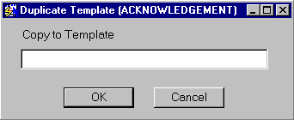

Copy Template

The COPY TEMPLATE button allows you to copy the currently selected template details along with all of its properties (Table Name, Media, Template Columns, etc). When you copy a template within Exor you must also copy the actual Microsoft Word template file (.dot) using the same filename as is used in the 'Copy to Template' field on the Exor form. You can then modify the template file and maintain its details to suit your requirements. Before the new template report may be produced, it must be assigned to the relevant user using ***Template Users - DOC0202***.

The selected Templates name you wish to duplicate is displayed on the windows title bar e.g. [ACKNOWEDGEMENT].

Copy to Template (Required)

Enter the name for the new template. You do not need to enter the '.dot' file extension.

Press [**OK**] to copy the template.

Check Template SQL

The [***Check Template SQL***] button validates the entries that have been made in the Columns for Templates window to ensure that the syntax used is correct i.e. no missing commas, brackets, etc.

If the entries are syntactically correct the following message will be displayed.

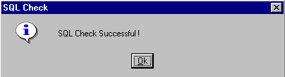

No corrective action needs to be taken.

If an error is encountered a message stating what the error is will be displayed e.g.

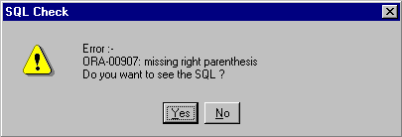

This error was caused because the right parenthesis was missing from an exor function used in the template. The function was entered as follows :

**COMPL\_SOURCE(DOC\_ID**

The correct syntax for this exor function should have been

**COMPL\_SOURCE(DOC\_ID)**

To find out where the error has occurred select [***Yes***] to the question 'Do you want to see the SQL ?' This will display an SQL error text window, displaying the checked SQL. You should look for the word '**Error →**' as this should indicate where the problem occurred.

Figure 17

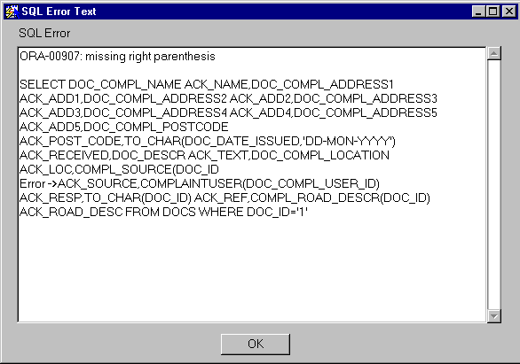SQL Error Text

Once the error has been located, click [**OK**] and edit the offending entry.

The most common problems arise through the miss typing of the 'Word Field Name' from that stored within the template. The [**Check Template SQL**] will not report any errors, but when the data is merged and the document is produced the field will be blank.

Template Users - DOC0202

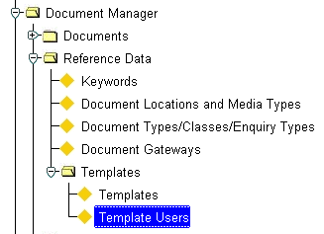Figure 18

Template Users

Menu Option

Before a template can be used to create a document from within ***Exor*** it must first be associated with the users who are allowed to use the template. This allows you to restrict access to particular templates to certain users.

Figure 19

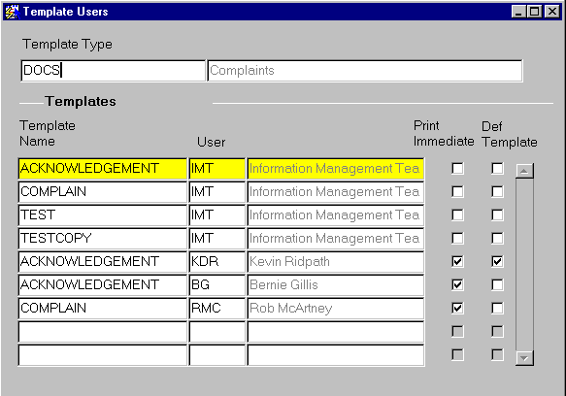Template Users

Template Type

When you enter this form the cursor sits in the 'Template Type' field. Press the[**Enter Query**]button on the toolbar to retrieve the Template Type you require.

Template Type (Required)

Enter the name of the Template Type e.g. for public enquiry templates enter 'DOCS', for Works Order Templates enter 'Works Orders'. Press the [**Execute Query**] button on the toolbar to retrieve the Template Type.

The Template Type Description will be displayed in the adjacent field along with details of any already logged templates.

Templates

This area of the form is used to set up access privileges for users who need to use particular templates. A user can only create documents using the templates that are assigned to them using this form.

Template Name (Required) (List)

Enter the Template Name you wish to give a user access to. The list of values will only display templates of the type selected in the 'Template Type' field.

User (Required) (List)

Enter the Users Initials of the user who can access this template. The users Name will be displayed in the adjacent field.

Print Immediate (Optional, Checkbox)

If this box is ticked, when the User creates a new document using this template, ***Exor*** will open MS Word and automatically print the document to the Users default printer. This means that the user will not be able to edit the document or the print properties.

Note that if this option is to be used the ‘Background Printing’ option within MS-Word must be unchecked as shown in Figure 20.

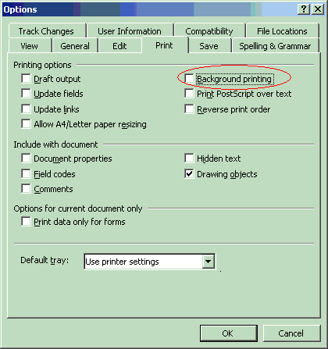Figure 20

Def Template (Optional, Checkbox)

If this box is ticked, it will make this template the default template for the User. When the user creates a new document from a template, this will automatically be the template name displayed in the 'Template Name' selection field. The user may also use any other templates they have been given access to. A user may only have one default template.

Exor Functions

Exor Functions available for use with 'DOCS' (Public Enquiry )Templates

|  |  |
| --- | --- |
| **Function Name and Parameters** | **Details Returned** |
| COMPLAINTUSER(USER\_ID) | Name of the User who logged the Complaint |
| COMPLAINTUSER(DOC\_COMPL\_USER\_ID) | Name of the User responsible for the Complaint. |
| COMPL\_ROAD\_DESCR(DOC\_ID) | The Section Description |
| COMPL\_ROAD\_UNIQUE(DOC\_ID) | The Section ID of the current Complaint |
| COMPL\_PRIORITY(DOC\_ID) | The decode text for the Priority Code |
| COMPL\_SOURCE(DOC\_ID) | The decode text for the Source Code |
| COMPL\_TYPE(DOC\_ID) | The decode text for the Complaint Type Code |
| COMPL\_FLAG(DOC\_ID) | The decode text for the Complaint Flag Code |
| COMPL\_STATUS(DOC\_ID) | The decode text for the Complaint Status Code |
| COMPL\_ADMIN\_CODE(DOC\_ID) | The Admin Unit code |
| COMPL\_ADMIN\_NAME(DOC\_ID) | The Admin Unit description |

Exor Functions available for use with 'WORK ORDERS' Templates

|  |  |
| --- | --- |
| **Function Name and Parameters** Details Returned | |
| **\*\*\*\*\*\*\*\* Works Order Top Level Functions \*\*\*\*\*\*\*\*** | |
| WWO.GET\_STD\_TEXT | |
|  | The Standard Text for the Work Description. This is set up in ***Product Options - HIG9130*** (WORSTDTXT) |
| **WWO.GET\_WORK\_ORDER(WOR\_WORKS\_ORDER\_NO)** | |
|  | The Works Order Number e.g. 2/00006 |
| **WWO.GET\_NETWORK\_IND(WOR\_WORKS\_ORDER\_NO)** | |
|  | Network Type Indicator i.e. D for Dtp Roads or L for Local roads |
| **WWO.GET\_ROAD\_GROUP(WOR\_WORKS\_ORDER\_NO)** | |
|  | Road Group on Works Order From e.g. 2900A69 1 |
| **WWO.GET\_ORDER\_TOTAL(WOR\_WORKS\_ORDER\_NO)** | |
|  | Total Works Order Cost |
| **WWO.GET\_ORDER\_SUB\_TOTAL(WOR\_WORKS\_ORDER\_NO)** | |
|  | Sub Total Cost for Works Order |
| **WWO.GET\_ORDER\_BAL(WOR\_WORKS\_ORDER\_NO)** | |
|  | Balancing Sum for Works Order |
| **WWO.GET\_CONTRACT(WOR\_WORKS\_ORDER\_NO)** | |
|  | Contract Name |
| **WWO.AUTHORISED\_BY(WOR\_WORKS\_ORDER\_NO)** | |
|  | Name of the User who authorised the Works Order. |
| **WWO.RASIED\_BY(WOR\_WORKS\_ORDER\_NO)** | |
|  | Name of User who raised the Works Order |
| **WWO.SCHEME\_TYPE(WOR\_WORKS\_ORDER\_NO)** | |
|  | Scheme Type of the Works Order |
| **\*\*\*\*\*\*\*\* Works Order Line Functions \*\*\*\*\*\*\*\*** | |
| **WWO.GET\_WORKS\_ORDER\_LINE(XX,WOR\_WORKS\_ORDER\_NO)** | |
|  |  |
| **WWO.GET\_DEFECT\_LOC\_FULL(WWO.GET\_WOL\_ID(XX,WOR\_WORKS\_ORDER\_NO))** | |
|  | Road Description, Defect Location, Defect Type and Defect Type Description, XSP, Chainage |
| **WWO.GET\_DEFECT\_LOC(WWO.GET\_WOL\_ID(XX,WOR\_WORKS\_ORDER\_NO))** | |
|  | Road Description, Defect Location, Defect Type and Defect Type Description |
| **WWO.GET\_DEFECT\_UNIT(WWO.GET\_WOL\_ID(XX,WOR\_WORKS\_ORDER\_NO))** | |
|  |  |
| **WWO.GET\_DEFECT\_QTY(WWO.GET\_WOL\_ID(XX,WOR\_WORKS\_ORDER\_NO))** | |
|  | Quantity for Selected Works Order Line |
| **WWO.GET\_DEFECT\_RATE(WWO.GET\_WOL\_ID(XX,WOR\_WORKS\_ORDER\_NO))** | |
|  | Rate for Selected Works Order Line |
| **WWO.GET\_DEFECT\_EST\_VALUE(WWO.GET\_WOL\_ID(XX,WOR\_WORKS\_ORDER\_NO))** | |
|  | Estimated Cost of Selected Works Order Line |
| **WWO.GET\_REPAIR\_TREAT(WWO.GET\_WOL\_ID(XX,WOR\_WORKS\_ORDER\_NO))** | |
|  | Defect Treatment Description for selected Works Order Line |
| **WWO.GET\_REPAIR\_DESC(WWO.GET\_WOL\_ID(XX,WOR\_WORKS\_ORDER\_NO))** | |
|  | Activity Code, Treatment Type and Description, Repair Description, Defect ID for selected Works Order Line |
| **WWO.GET\_DEFECT\_ID(WWO.GET\_WOL\_ID(XX,WOR\_WORKS\_ORDER\_NO))** | |
|  | Defect ID of selected Works Order Line |
| **WWO.GET\_WOL\_ID(XX,WOR\_WORKS\_ORDER\_NO)** | |
|  |  |
| **WWO.GET\_WOL\_LINK(WWO.GET\_WOL\_ID(XX,WOR\_WORKS\_ORDER\_NO))** | |
|  | Link Id (including Agency code) of the selected Road Section |
| **WWO.GET\_WOL\_SECTNO(WWO.GET\_WOL\_ID(XX,WOR\_WORKS\_ORDER\_NO))** | |
|  | Road Section Number of the Selected Works Order Line |
| **WWO.GET\_WOL\_ROAD\_SECTION(WWO.GET\_WOL\_ID(XX,WOR\_WORKS\_ORDER\_NO))** | |
|  | Link Id (Including Agency Code) and Road Section Number for the selected Works Order Line |
| **WWO.GET\_WOL\_ITEM\_NO(XX,WOR\_WORKS\_ORDER\_NO)** | |
|  |  |
| **WWO.GET\_WORK\_CATEGORY(WWO.GET\_WOL\_ID(XX,WOR\_WORKS\_ORDER\_NO))** | |
|  |  |
| **WWO.GET\_DEFECT\_ACTIVITY(WWO.GET\_WOL\_ID(XX,WOR\_WORKS\_ORDER\_NO))** | |
|  | The Defect activity of the defect on the selected Works Order Line. |
| **WWO.GET\_DEFECT\_CODE\_DESCR(WWO.GET\_WOL\_ID(XX,WOR\_WORKS\_ORDER\_NO))** | |
|  |  |
| **WWO.GET\_TREATMENT\_DESC(WWO.GET\_WOL\_ID(XX,WOR\_WORKS\_ORDER\_NO))** | |
|  |  |
| **WWO.GET\_DEFECT\_LINE(WWO.GET\_WOL\_ID(XX,WOR\_WORKS\_ORDER\_NO))** | |
|  | |
| \*\*\*\*\*\*\*\* BOQ Line Functions derived from work order line \*\*\*\*\*\*\*\* | |
| **WWO.GET\_BOQ\_QTY(XX,WWO.GET\_WOL\_ID(XX,WOR\_WORKS\_ORDER\_NO))** | |
|  | Total Quantity for selected BOQ Line of Selected Works Order Line |
| **WWO.GET\_BOQ\_UNIT(XX,WWO.GET\_WOL\_ID(XX,WOR\_WORKS\_ORDER\_NO))** | |
|  | Unit of Measurement for selected BOQ Line of Selected Works Order Line. |
| **WWO.GET\_BOQ\_TOTAL(XX,WWO.GET\_WOL\_ID(XX,WOR\_WORKS\_ORDER\_NO))** | |
|  | Total Cost of selected BOQ line of selected Works Order Line |
| **WWO.GET\_BOQ\_LINE\_TOTAL(WWO.GET\_WOL\_ID(XX,WOR\_WORKS\_ORDER\_NO))** | |
|  | Total Cost of selected BOQ line of selected Works Order Line and the word 'Total :' |
| **WWO.GET\_BOQ\_RATE(XX,WWO.GET\_WOL\_ID(XX,WOR\_WORKS\_ORDER\_NO))** | |
|  | Rate for selected BOQ line of selected Works Order Line. |
| **WWO.GET\_BOQ\_ITEM(XX,WWO.GET\_WOL\_ID(XX,WOR\_WORKS\_ORDER\_NO))** | |
|  | Item Code for selected BOQ Line of selected Works Order Line |
| **WWO.GET\_BOQ\_DESC(XX,WWO.GET\_WOL\_ID(XX,WOR\_WORKS\_ORDER\_NO))** | |
|  | Full Description of Item Code for selected BOQ Line of selected Works Order Line |
| **WWO.GET\_BOQ\_LINE(XX,WWO.GET\_WOL\_ID(XX,WOR\_WORKS\_ORDER\_NO))** | |
|  | Item Code, Item Code Description, Unit of measurement, rate, Total Quantity, Total Cost for BOQ line |
| **WWO.GET\_BOQ\_EST\_COST(XX,WWO.GET\_WOL\_ID(XX,WOR\_WORKS\_ORDER\_NO))** | |
|  | The total Estimated Cost for selected BOQ Line of selected Works Order Line |
| **WWO.GET\_BOQ\_EST\_QUANTITY(XX,WWO.GET\_WOL\_ID(XX,WOR\_WORKS\_ORDER\_NO))** | |
|  | The Total estimated Quantity for selected BOQ line of selected Works Order Line |
| **WWO.GET\_BOQ\_EST\_RATE(XX,WWO.GET\_WOL\_ID(XX,WOR\_WORKS\_ORDER\_NO))** | |
|  | The estimated Rate for selected BOQ line of selected Works Order Line |
| **WWO.GET\_BOQ\_ACT\_COST(XX,WWO.GET\_WOL\_ID(XX,WOR\_WORKS\_ORDER\_NO))** | |
|  | The Actual Cost for the selected BOQ Line of the selected Works Order Line |
| **WWO.GET\_BOQ\_ACT\_QUANTITY(XX,WWO.GET\_WOL\_ID(XX,WOR\_WORKS\_ORDER\_NO))** | |
|  | The Actual Quantity for the Selected BOQ Line of the selected Works Order Line |
| **WWO.GET\_BOQ\_ACT\_RATE(XX,WWO.GET\_WOL\_ID(XX,WOR\_WORKS\_ORDER\_NO))** | |
|  | The Actual Rate for the selected BOQ line of the selected Works Order Line. |

Note XX is the Integer value of the WO/ BOQ

Index

C

Check Template SQL 31, 32

Copy Template 30

**Create from New** 4, 8, 9

Creating a MS Word Template 17

Creating a Word Template 16

D

Display 5, 29

DOC\_CATEGORIES 5

Document Associations 3, 4, 5, 6, 8, 14

Document Details 1, 10

***Document Types*** 5

***Documents - DOC0100*** 4, 5, 8, 11

E

Exor Functions 35, 36

P

Prerequisites 15

T

Template Columns 28, 29, 30

Template Users 6, 30, 33

Templates 14, 16, 18, 19, 21, 27, 29, 30, 31, 33, 34, 35, 36